12 Way Horizontally Mounted Rackmount IEC 20 Plug PDU - IEC 13 Sockets (PDU-12WS-H-IEC-IEC20)

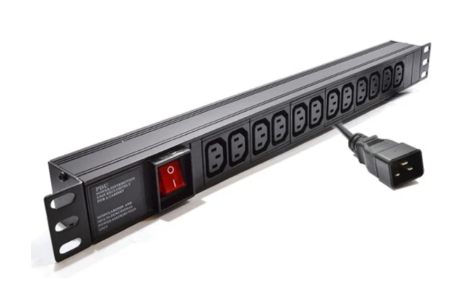

Description:
The LMS Power PDU-12WS-H-IEC-IEC20 is a high-quality horizontally mounted PDU (Power Distribution Unit) that simply fits within the universal mounting brackets of data, telecom and server cabinets.
A must-have accessory for your data cabinets if you need to provide effective power to devices including Ethernet Switches, Servers, UPS, NAS and of course cabinet accessories including cooling fan trays.
Robust, alloy design complete with rackmount brackets fitted, high-quality Neon Switch, standardised IEC 13 power outlets, the PDU being fitted with a standardised IEC 20 Plug.

Key Features:
Standard IEC 13 power outlets for your appliances
Standardised IEC 20 power plug
1U horizontally mounted attaches to internal profiles
Neon On/Off Rocker switch to prevent accidental turn off
Backed up by LMS Power's exclusive 3-year warranty

Applications:

Create instant power feeds to your data, telecom or server cabinets

Provide effective power for cabinet cooling fans, UPS systems

Ideal as stand-alone trailing sockets outside the cabinet

Product Code:
Part Number: PDU-12WS-H-IEC-IEC20
EAN: 8400800030702
Weight: 1.7Kg approx

Technical Specifications:
Warranty LMS Data 3-Year Warranty
Chassis 1U horizontally PDU with mounting brackets
Output Sockets 12 IEC 13 Sockets
Power Input Standardised IEC 20 Plug
Flex Length 2 metres (approx)
Power Control On/Off Rocker Switch (illuminated)
Power Rating 4000 Watts (approx) Surge Protected

Supplied With:
PDU-12WS-H-IEC-IEC20 12 Way Horizontal PDU
Cabinet brackets (Fitted)
* Specifications and product design are subject to change. E&OE.

Looking for a more specialised, higher density Power Distribution Unit (PDU) to provide power to a wide variety of devices? The new LMS Data PDU-12WS-H-IEC-IEC20 is a high-density, horizontal placement PDU which features 12 standard IEC-C13 socketed outlets to provide power to networking, data centre, PBX and broadcast level power devices within the data cabinet enclosure. Horizontal placement within almost any type of 19-inch wide wall, telco or server enclosure is assured thanks to its universal design together with a host of mounting options within the enclosure. Coupled with a long-life, illuminated I/O Switch, certified power sockets together with a generous length power cord to the attached IEC-C20 power input plug.

specifications:
12-way IEC-C13 Socket Power Distribution Unit (PDU)
Compliant, IEC-C20 power input plug
Illumination On/Off power-input rocker switch
Integral Grounding built into the chassis
Generous length, 1.8 metre (approx.) power cable
Lightweight, horizontal design with mount brackets
Ideal for horizontal placement in data or server enclosures
Ideal for LAN, audio-visual, PBX, VoIP and CCTV applications

